**Read me first!**

**Instructions**

1. All text in blue in the resume template should eventually be replaced and changed to black font.
2. You are free to customise your resume layout, sequence, fonts, which sections to include/exclude, et cetera. This is only a suggested resume format.
3. Keep your resume to **within 2 pages.**
4. Do additional research on effective ways of writing up the different sections of your resume

**Please delete Pages 1 to 3 before submitting your resume for CA.**

**- Please delete this page before your CA submission -**

Keep the Following in Mind as You Craft Your Resume

1. **Contact details**

* Use a name that appears in your Student ID
* You may use your school’s email for an internship application
* Ensure contact details are accurate
* Ensure you have updated your LinkedIn Profile before including the URL

1. **Internship Objective**

* An objective can help the hiring manager to gain a better understanding of why you are applying for this internship position
* Companies hire you as an intern so that you can contribute
* Focus on the following:
  + **skills** (generic skills like problem-solving, team-work etc.)
  + **training** (technical skills from the course that you are in)
  + **experience** (part time and ongoing free-lance jobs that you may have) that you can bring as an intern.

1. **Summary of Key Skills**

* Write in bullet points the key skills that you can bring to the company
* It may be easier to write up this section after you have completed the section on experience

1. **Technical Skills**

* Spell out acronyms in full because a non-technical recruiter may be reading
* List all your technical or computer skills
* List related technical skills to show your versatility
* List skills in Microsoft Office (Excel, Word, PowerPoint) only if you have more than basic skills in these software

1. **Critical Core Skills**

* <https://www.skillsfuture.gov.sg/initiatives/early-career/criticalcoreskills>
* List down your critical core skills that are relevant to the job

1. **Language Proficiency**

* Share level of proficiency for written and spoken languages
* e.g. Proficient in English and Mandarin, spoken and written

1. **Education**

* Use reverse chronological order
* Provide the anticipated graduation date for your diploma
* Include your GPA if it is 3.0 and above and if you feel that it puts you in a good light
* You can consider listing some of the relevant modules that you took that matches the requirements of the internship position

**- Please delete this page before your CA submission -**

1. **Work Experience**

* Use the reverse chronological order
* Use some form of hierarchy through the use of **bold text** and **bullet points**
* Be consistent throughout
* Use appropriate action verbs and key phrases to highlight your competencies and skills
* Use numbers to show you have a proven track record. Numbers and measurements can apply to job functions.
* Examples using numbers to quantify track record:
  + Inspired a team of 5 baristas to perform their best
  + Received 3 commendations for providing excellent customer service
* Examples using action verbs to show track record:
  + Demonstrated empathy and problem-solving skills when addressing customers’ complaints
  + Coached baristas in areas where mistakes were made

1. **Volunteer and Leadership Experience (If any)**

* Use reverse chronological order
* IG / CCA experience can also be included if you have performed duties as part of your involvement in your IG / CCA
* Include your position in the IG/ CCA that you have participated
* Use action verbs to showcase skills that you want to bring attention to

1. **Achievements & Awards (Optional)**

* Use reverse chronological order
* This should showcase your achievements and awards received, such as winning any national, regional or international competitions or tournaments, awarded Scholarships etc.
* If you have a long list, choose the latest and most significant
* Do not include workshops and training camps you have attended
* If you have input in this section, please remove the word “(Optional)”

**References**

* You may use a one-liner, “Available upon request”
* Do not list details of your referee that you have obtained permission. You only release such information when hiring company request for them.
* Complete the resume with an “– End –“ This is to indicate the end of your document.
* Overall, be consistent in your language – e.g. keeping to UK English throughout.

**- Please delete this page before your CA submission –**

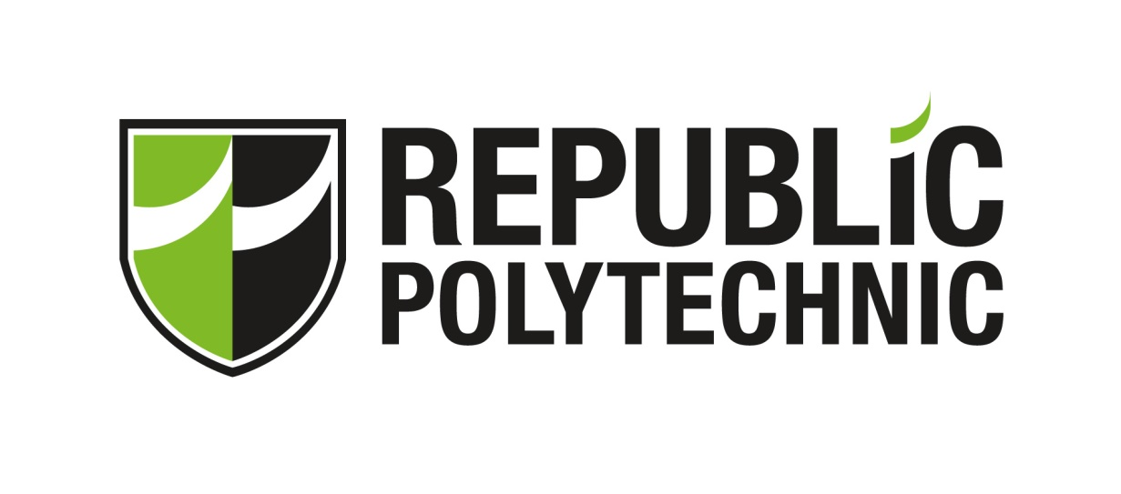

**G962 CONTINUOUS ASSESSMENT (CA) AY2023 SEM 2**

**DECLARATION**

|  |  |
| --- | --- |
| Full name: | Nurmarsyita Binte Ramlan |
| Student ID: | 22038005 |
| Module | **G962 ECG II: Becoming Future-Ready** |
| Date of Submission: |  |
| I declare that:   * This submission is my original work – all sources have been properly referenced and acknowledged. * I have not copied the words or graphics or codes from another person/source and submitted it as my own. * I neither received nor rendered any assistance *(either paid or unpaid)* on work that requires individual effort. * I have not communicated, discussed, shared or made available my work with other students, in part or in whole, formally or informally. By doing so, I am also guilty of plagiarism and cheating.   If found guilty of committing any act of academic dishonesty, I understand that I will be liable:   * For disciplinary action by the School. * To the full extent of penalties, including but not limited to immediate failure for this assessment and other disciplinary actions such as dismissal. | |

Name: Nurmarsyita Binte Ramlan

Email: 22038005@myrp.edu.sg

Mobile: 90052744

https://www.linkedin.com/in/nurmarsyita/

**Internship Objective**

I am a motivated second year student pursing in Digital Design and Development seeking an internship as a web designer, UI developer, or web developer. Dedicated to learning and developing my skills in IT and contributing to a team. Self-directed and energetic, learning new things and exploring new avenues. Offers excellent communication and organizational skills along with skills in UI development and programming and fluent in virtual work.

**Summary of Key Skills**

|  |  |
| --- | --- |
| * Programming languages (Python, Java,   JavaScript, etc.)   * Databases (MySQL) * HTML, CSS * UX design * UI design | * Creativity * Verbal communication * Listening * Teamwork * Software literacy * Social media literacy |

**Education**

**Republic Polytechnic (Apr 2022 – Present)**

Diploma in Digital Design and Development

**Institute Of Technical Education (Apr 2020 – Mar 2022)**

Higher Nitec in IT Applications Development

**Institute Of Technical Education (Jan 2018 – Dec 2019)**

Nitec in Web Application

**Northland Secondary School (Jan 2014 – Dec 2017)**

N-Level Certification

**Work Experience**

**Bata Aug 2023 – Present**

**Sales Assistant**

* Collaborated with team members to achieve sales goals.
* Assisted customers with trying on shoes and provided size recommendations.
* Greeted customers warmly and engaged in friendly conversations to understand their needs and preferences.

**Resorts World Sentosa Nov 2022 – Dec 2022**

**F&B Crew**

* Assist in food and beverage preparation, following recipes and instructions.
* Set up tables, arrange cutlery, and ensure a visually appealing dining environment.
* Collaborate and communicate effectively with fellow crew members and kitchen staff.

**Fssocom Dec 2021 – Feb 2022**

**Retail Assistant Inten**

* Process sales transactions, handle payments, and provide excellent customer service throughout the purchasing process.
* Stay organized and maintain inventory of electronic parts, ensuring stock availability and assisting in ordering replenishment when necessary.
* Organize and maintain a systematic filing system for past and present receipts, ensuring easy retrieval and record-keeping.

**Tribal Studioz Mar 2019 – May 2019**

**Web Design Intern**

* Gathered specifications and other key details to meet requirements of site development.
* Designed user interface to meet client specifications and content management system.
* Produced sample sites and received feedback about draft sites.

**Volunteer and Leadership Experience**

**Institute Of Technical Education Mar 2018 – Aug 2018**

**Malay Dance, Team Player**

* Participated in National Day 2018
* Demonstrated a strong commitment to teamwork, working collaboratively with other dancers to achieve a cohesive and impactful performance.

**Institute Of Technical Education Nov 2019 – Nov 2019**

**Volunteering**

* Friend Of Silver Infocom (Infocom Media Development Authority)
* Actively participated in workshops and training sessions, gaining knowledge and skills to effectively assist seniors in their digital journey.
* Encouraged seniors to practice their newly acquired skills, fostering their confidence and independence in the digital world.

**Northland Secondary School Jan 2014 – Dec 2016**

**Prefectorial Board (Junior Prefect)**

* Working together with other prefects and school staff to plan and coordinate activities.
* Organizing and leading school events

**Achievements & Awards (Optional)**

* Edusave Certificate of Academic Achievement 2022
* Edusave Good Progress Award 2021
* Edusave Awards for Achievement, Good Leadership and Service 2017
* Certificate of Accomplishment (Singapore Youth Festival) 2015 & 2017

**Micro and Alternative Credentials**

* Software Testing Foundations: Test Planning Oct 2023
* Software Testing Foundations: Test Techniques Oct 2023

**References**

Available upon request

– End –